

58

Target: ___/58 or ____ % 👍 👎

Year 8 HASS- Economics and Business

***Task 5: In-Class Multiple Choice, Short Answer and Extended Answer Responses (7.5% weighting)***

***Name: ____________________ Teacher: ________________***

**Time: 5 minutes reading time and 45 minutes working time.**

**Section One: Multiple Choice**

**Read each key term, or statement, and circle only one option as your response.**

**(22 marks)**

1. Which of the following **is not** a key concept of economics and business?
   1. Scarcity
   2. Making choices
   3. Space
   4. Allocation and markets
2. ‘Consumers’ are best defined as:
   1. Things that are bought and sold
   2. People or groups that are the final users of goods and services
   3. The organised exchange of goods and services by buyers and sellers
   4. People and businesses who make or produce goods and services
3. Which four factors of production are considered resources in an economy?
   1. Land, labour, capital, enterprise
   2. Food, labour, land, enterprise
   3. Services, labour, land, capital
   4. Needs, land, capital, enterprise
4. ‘Producers’ are best defined as:
   1. Things that are bought and sold, tangible items
   2. People or groups that are the final users of goods and services
   3. The organised exchange of goods and services by buyers and sellers
   4. People and businesses who make or produce goods and services
5. ‘Goods’ are best defined as:
   1. Things that are bought and sold, tangible items
   2. People or groups that are the final users of goods and services
   3. The organised exchange of goods and services by buyers and sellers
   4. People and businesses who make or produce goods and services
6. ‘Needs’ are best defined as:
   1. Systems supplying a public need, such as transport, non-tangible items
   2. A good or service that is desired but is not necessary for survival or to meet the basic standard of living in a community
   3. Goods or services that are necessary for consumers to keep alive
   4. The exclusive control by one group or company of the market for a good or service
7. ‘Services’ are best defined as:
   1. Systems supplying a public need, such as transport, non-tangible items
   2. A good or service that is desired but is not necessary for survival or to meet the basic standard of living in a community
   3. Goods or services that are necessary for consumers to keep alive
   4. The exclusive control by one group or company of the market for a good or service
8. ‘Wants’ are best defined as:
   1. Systems supplying a public need, such as transport, non-tangible items
   2. A good or service that is desired but is not necessary for survival or to meet the basic standard of living in a community
   3. Goods or services that are necessary for consumers to keep alive
   4. The exclusive control by one group or company of the market for a good or service
9. Who makes up the household sector in an economy?
   1. Consumers
   2. The government
   3. The overseas sector
   4. Businesses
10. Who makes up the firm’s sector in an economy?
    1. Consumers
    2. The government
    3. The overseas sector
    4. Businesses
11. Which of the following are types of markets in Australia?
    1. Agricultural
    2. Financial
    3. Stock
    4. Housing
    5. Wholesale
    6. Retail
    7. All of the above
12. Which of the following **is not** considereda good?
    1. Pencil case
    2. Basketball
    3. Hair cut
    4. Shoes
13. ‘Markets’ are best defined as:
    1. Things that are bought and sold, tangible items
    2. People or groups that are the final users of goods and services
    3. The organised exchange of goods and services by buyers and sellers
    4. People and businesses who make or produce goods and services
14. Which of the following **is not** considered a service?
    1. An electrician fixing your light switch
    2. A hairdresser giving you a haircut
    3. Buying lollies at the shop
    4. Getting a check-up at the dentist
15. Which of the following products would be considered a need?
    1. iPhone
    2. Computer
    3. Basketball
    4. Basic food
16. Which of the following products would be considered a want?
    1. Basic food
    2. Basketball
    3. Fresh water
    4. Shelter
17. If a product is really popular and many people want to buy it, we would say it is in __________________.
    1. Low demand
    2. High demand
    3. No demand
    4. Fashion
18. Machinery used in a mechanic’s workshop is known as which factor of production?
    1. Land
    2. Labour
    3. Capital
    4. Enterprise
19. Trees used to make paper are known as which factor of production?
    1. Land
    2. Labour
    3. Capital
    4. Enterprise
20. If a natural disaster like a cyclone destroys most of the banana crops in Australia, the price of bananas will most likely:
    1. Increase
    2. Decrease
    3. Stay the same
    4. All of the above
21. If the supply of a product decreases, the price of the product will most likely:
    1. Increase
    2. Decrease
    3. Stay the same
    4. All of the above
22. If the demand of a product decreases, the price of the product will most likely:
    1. Increase
    2. Decrease
    3. Stay the same
    4. All of the above

**Section Two: Short Answer**

1. Economics and Business key concepts matching activity – Write the letter of the correct definition next to the number. (6 marks)
2. ___________
3. ___________
4. ___________
5. ___________
6. ___________
7. ___________

|  |  |
| --- | --- |
| **Concept** | **Explanation** |
| **1**  Scarcity | **A)** Economists measure how well a country’s economy is doing based on certain measurements, including Gross Domestic Product (GDP), inflation rates, and unemployment rates. Economists also look at how economics and peoples’ quality of life are related. |
| **2**  Making Choices | **B)** Refers to the way scarce resources are distributed among producers and consumers. Resources are exchanged in a certain place where buying and selling takes place. |
| **3**  Allocation and Markets | **C)** Decisions made about what we want to buy to satisfy our needs and wants. These decisions can be small, such as what we will buy for our lunch, or big, such as whether or not to buy a house. |
| **4**  Interdependence | **D)** Refers to the way different parts of the economy rely on others to satisfy wants and needs. |
| **5**  Specialisation and Trade | **E)** Exists when there is not enough of something (product/service/resource) to satisfy everyone’s wants, at a zero price (for free). |
| **6**  Economic Performance and Living Standards | **F)** Refers to the way an individual, business, or country can focus on the production of a particular good or service in order to develop a more efficient production process. If an individual, business, or country does not have a product they need, they may trade with other parts of the economy. |

1. Complete the blank circular flow diagram showing the key participants in an economy.

(15 marks)

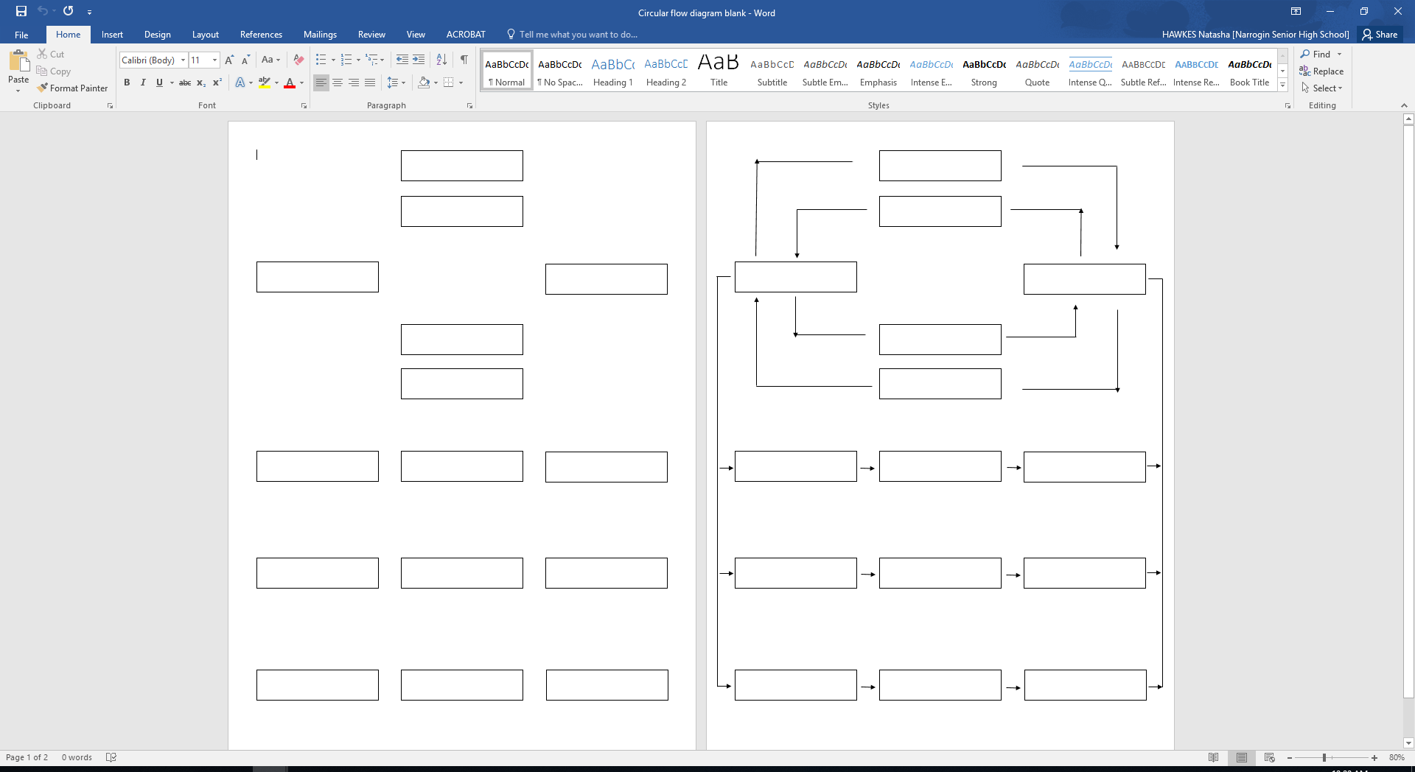

1. Outline what the study of Economics and Business is and provide one example to support your response. (3 marks)

1. Explain what the consumer provides to the producer and what the producer provides to the consumer. (6 marks)

1. Choose **one** of the following key participants in the economy and explain how they interact within the economy. (6 marks)

* The household sector
* The firms sector
* The government sector
* The financial sector
* The overseas sector

Key participant: _____________________________________ (1)

Explanation: (5)

**END OF TEST**